IAM Task
Task: 1. Create one IAM user and assign EC2 and S3 full access roles.

Objective
To create an IAM (Identity and Access Management) user in AWS and grant the user full access to Amazon EC2 and Amazon S3 services using AWS managed policies.

Prerequisites
- An active AWS account
- Administrator access to the AWS Management Console
- Internet connection
- A supported web browser
Step 1: Log in to the AWS Management Console
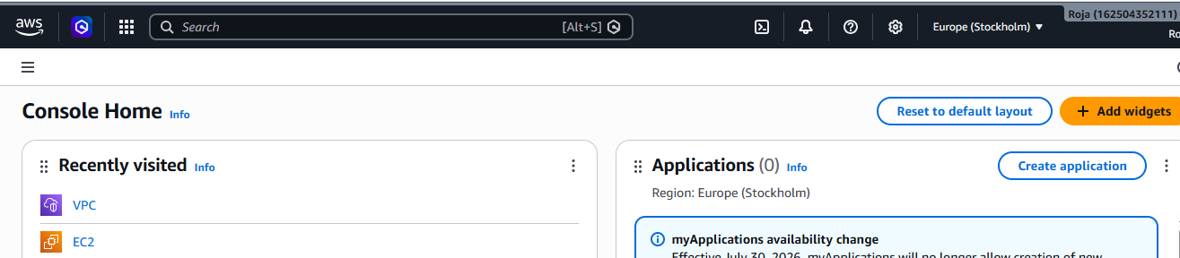

Step 2: Open the IAM Console
- In the AWS Console search bar, type IAM.
- Click IAM from the search results.
- The IAM Dashboard opens.
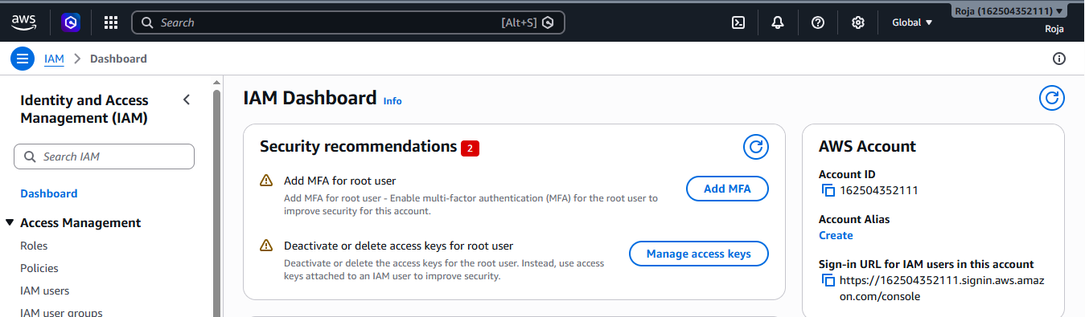

Step 3: Create an IAM User
- In the left navigation pane, click IAM Users.
- Click Create user.
Enter the details:

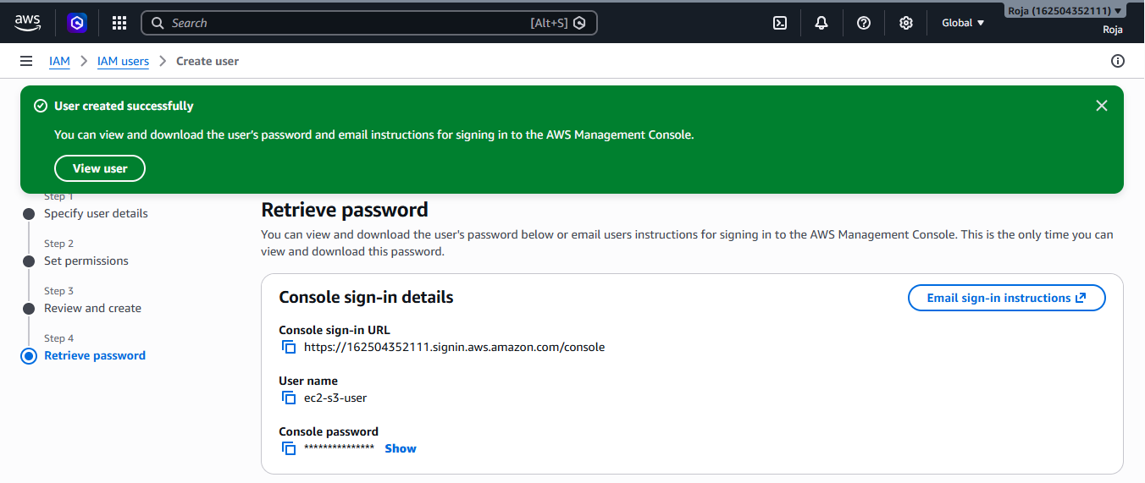
Step 4: Obtain User Sign-in Details

Console sign-in URL: IAM user login url (https://162504352111.signin.aws.amazon.com/console)
User name: ec2-s3-user
Console password: Generated or custom password (Devops@123)
Provide these credentials to the IAM user.

Step 5: Verify Attached Permissions
- Navigate to IAM → Users.
- Select ec2-s3-user.
- Open the Permissions tab.
- Confirm that the following policies are attached
Amazonec2FullAccess Attached.
AmazonS3FullAccess Attached

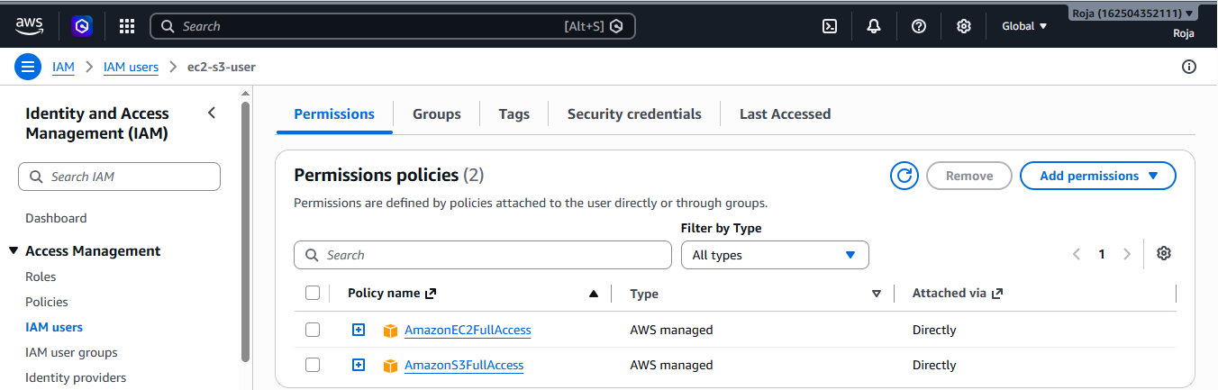
Task: 2. Create one group in IAM and assign read access for EC2.

Objective
To create an IAM group in AWS and assign read-only access to Amazon EC2 by attaching the AWS managed policy AmazonEC2ReadOnlyAccess. This allows users in the group to view EC2 resources without the ability to create, modify, or delete them.

Prerequisites
- An active AWS account
- Administrator or IAM user with permission to manage IAM resources
- Internet connection
- A supported web browser

Step 1: Open the IAM Console

In the AWS Management Console search bar, type IAM.

Select IAM from the search results.

The IAM Dashboard opens.

Step 2: Create an IAM Group
- In the left navigation pane, click IAM User groups.
- Click Create group.
Enter the details:
Group name – EC2 ReadOnly Group
Add users to group – Select the user to be added
Attach permission policies
3. Click on create group.
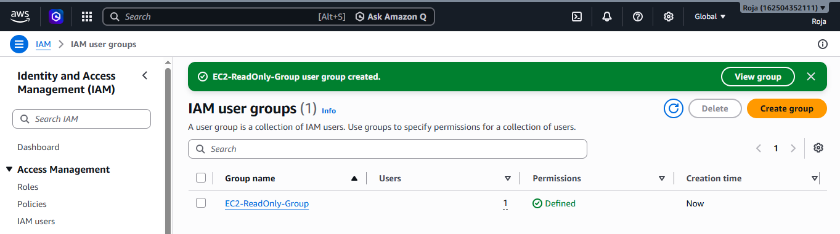
Step 3: Verified and see that user is added to the Group:

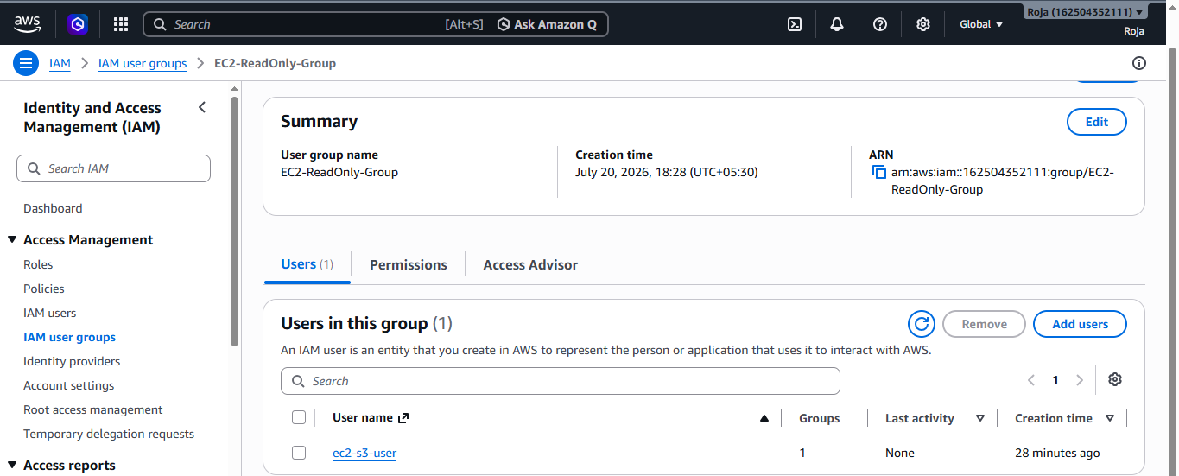

Step 4: Verify Group Permissions
- Navigate to IAM → User groups.
- Select EC2-ReadOnly-Group.
- Open the Permissions tab.
- Confirm that the following policy is attached
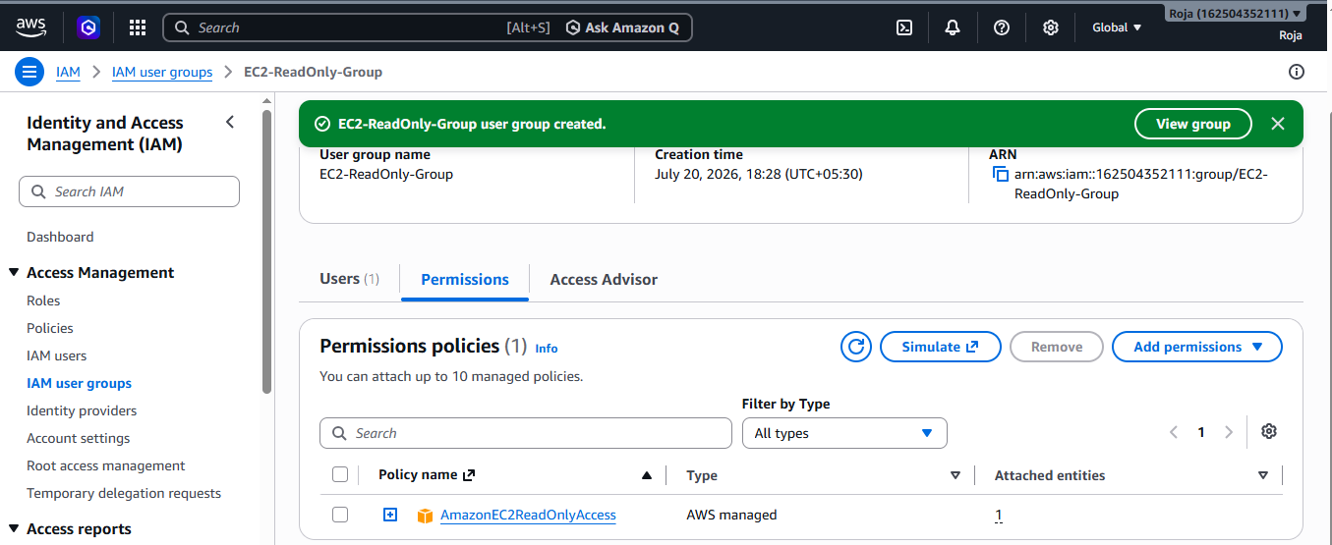

Task : 3. Create a new user named "Devops" and add to the group created in task 2.
Objective :
To create a new IAM user named Devops and add the user to the IAM group created in Task 2 (for example, EC2-ReadOnly-Group) using the AWS Management Console.

Prerequisites
- AWS Account with administrator access.
- IAM group already created in Task 2 (e.g., EC2-ReadOnly-Group).

Step 1: Open IAM Service
- In the AWS Console search bar, type IAM.
- Select IAM from the search results.
- In the left navigation pane, click Users.
- Click Create user.
- Create an IAM user and fill the details.
- Click on create user.

Step 2: Add User to Existing Group
- On the Set permissions page, select:
Add user to group
- From the list of available groups, select the group created in Task 2.
EC2-ReadOnly-Group
3. Click Next.

